Betweener Header Pinouts

Betweener V1.1.0

|  |  |  |  |  |  |  |
| --- | --- | --- | --- | --- | --- | --- |
| Expansion Header | | | | | | |
| **PIN14**  +3.3V | **PIN13**  GND | **PIN12**  D8(LED) | **PIN11**  D33(touch) | **PIN10**  D31/A20  (serial2 Tx for DINMIDI) | **PIN9**  D25(touch)PWM | **PIN8**  D27/A16 |
| **PIN1**  +5VNC | **PIN2**  GND | **PIN3**  A14/DAC | **PIN4**  D32(touch)/PWM | **PIN5**  D24 | **PIN6**  D26/A15(serial2 Rx for DIN MIDI) | **PIN7**  D28/A17 |

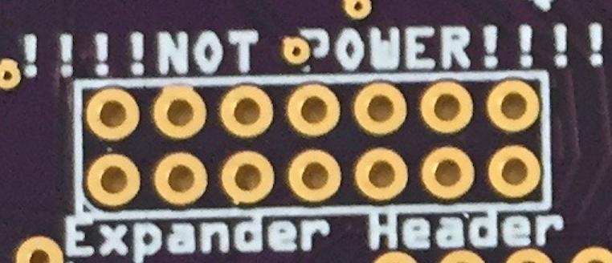

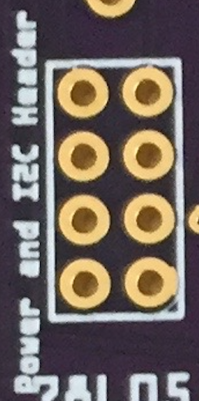

|  |  |  |  |
| --- | --- | --- | --- |
| (bottom end) I­2C Header | | | |
| PIN8 GND | PIN7 +5V | PIN6 +3.3V | PIN5 D29 |
| PIN1 GND | PIN2 +5V | PIN3 +3.3V | PIN4 D30 |